Embry-Riddle Language Institute EGM 003

Name: _____________

Diagnostic Test

Out of 34 points

Part A: [12 points]
Start a short story in the past and then move to the present and then the future. Use the story guide below:

Last month Jane decided to take a vacation . . .
(1) Use each of the following verb tense forms:
simple past x 1 simple present x 1 simple future x 1
past continuous x 1 present continuous x 1 future continuous x 1
past perfect x 1 present perfect x 1 future perfect x 1
past perfect continuous x 1 present perfect continuous x 1 future perfect continuous x 1
______________________________________________________________________________

Part B: Gerunds & Infinitives [5 points]
Use the verbs below to write complete sentences. Put a gerund or infinitive after each verb.

1. (forget) (1 point)
2. (want) (1 point)
3. (plan) (1 point)
4. (enjoy) (1 point)

Gerund and Infinitive Subjects: Use the verbs below to make subjects for a sentence.

1. (to sleep) (1 point)
2. (studying) (1 point)
Part C: Present Modals [3 points] Use the below to write 3 present modal sentences telling about the things in the picture.

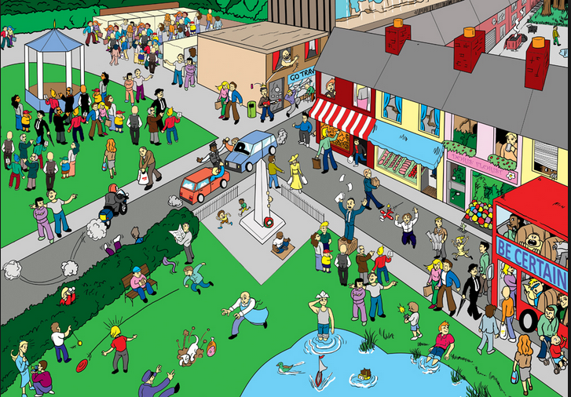
1. present simple: [must] (1 point)
2. present continuous: [could] (1 point)
3. present continuous: [question] (1 point)
Part D: Past Modals [2 points]
In the situation below something has happened that makes Tom feel blame, regret, make a possibility or make a guess about the past. Make a sentence with a past modal.

Last night, Jane received a phone call from Tom. She was really surprised as they had not seen each other in a long time. While they were talking, they decided to go out on Monday. When Monday came, Jane was all dressed up, and she was waiting on Tom to come and pick her up. Three hours passed, and Tom was not there. She thought that he probably had forgotten about their meeting. Jane decided to call him to find out. As soon as she picked up the phone, the doorbell rang. She ran to the door hoping it was Tom. But it was not Tom, it was a policeman and he had bad news. Tom was driving very fast to make it on time to Jane, and he got into a car accident. Jane could not stop crying . . .
- past simple possibility: (1 point)

- past continuous (had better): (1 point)

Part E: Adverb Clauses [7 points]
Use the picture I gave you to make sentences with adverb clauses. Use the words given.
Reason:

- [as] (1 point)

Time:

- [while] (1 point)

- [since] (1 point)

- [once] (1 point)

- [by the time] (1 point)
Contrast:
- [whereas] (1 point)

Unexpected Result:

- [though] (1 point)

Part F: Real Conditionals [3 pts] Write real conditional sentences about anything in the picture.
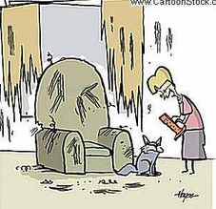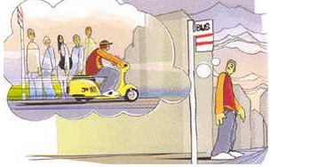
http://www.michellehenry.fr/condition.htm
- [past habit] (1 point)

- [present habit] (1 point)

- [future prediction] (1 point)

Part I: Adjective Clauses [2 points] Choose 2 things from any picture in the test, and write 2 adjective clause sentences that describe those things. Underline the adjective clauses.
- S-S: (1 point)

- O-S: (1 point)

