Part A: Verb Tenses (12 points)
Start a short story in the past, then move to the present, and finish it in the future. Use the story guide below:
- Last month, Alex decided to take a vacation…
Use each of the following verb tense forms (1 point each x 12 = 12 points total):
simple past simple present simple future
past continuous present continuous future continuous
past perfect present perfect future perfect
past perfect continuous present perfect continuous future perfect continuous
______________________________________________________________________________

Part B: Gerunds and Infinitives (6 points)
Use the verbs below to write sentences. Put a gerund or infinitive after each verb.
- want
- avoid
- enjoy
- tell
Use the verbs below to make subjects for a sentence.
- To learn
- Writing

Part C: Present and Past Modals (5 points)
Use the picture below to write three (3) sentences using present modals. Only write about the picture.
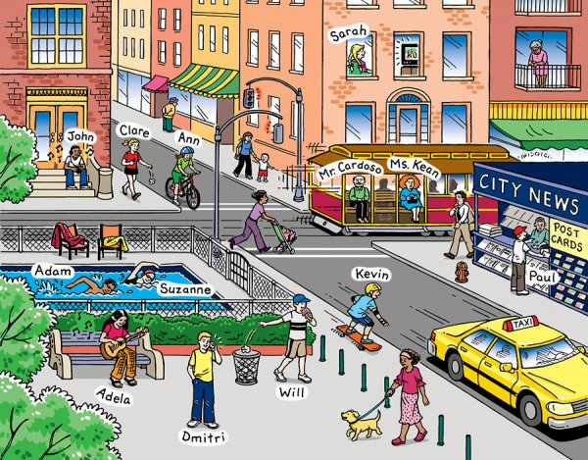

- Simple Present (advice)
- Present Continuous (possibility)
- Simple Present (question)
Use the story below to make two (2) sentences using past modals.
Last night, Tyler received bad news from his sister. Something happened to her and she will move to Florida in two weeks. In the past, they hung out every week because they both lived in Atlanta. He asked his sister why she was moving, but she won’t tell him.

- Simple Past (should)
- Past Continuous (must)

Part E: Adverb Clauses (6 points)
Use the picture in Part D to make sentences with adverb clauses. Use the words given. Only write about the picture.

Reason:

- since

Time:

- while
- by the time
- until
Contrast:

- whereas

Unexpected Result:

- even though

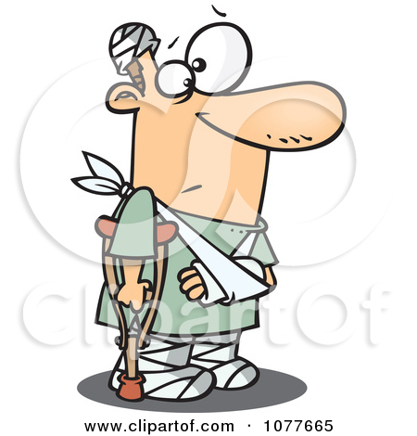
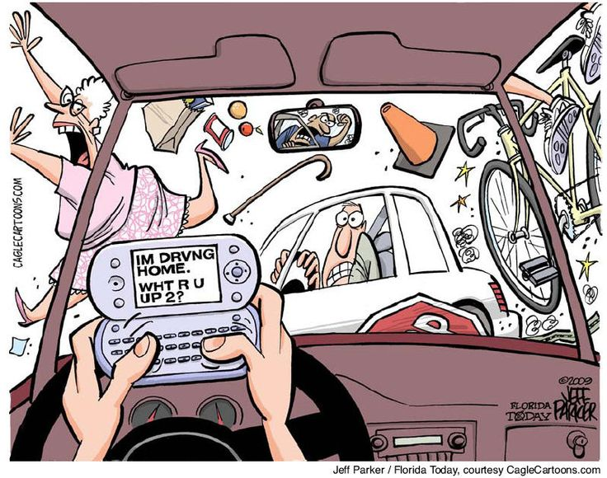
Part F: Conditionals (4 points)
Write a past real conditional sentence about a habit. Only write about the picture.

- ______________________________________________________________________

Write a future real conditional sentence about a prediction. Only write about the picture.

- ______________________________________________________________________

Write present unreal conditional sentences about a present habit. Only write about the picture.

- [simple] _______________________________________________________________

- [continuous]____________________________________________________________

Part G: Adjective Clauses [2 points] Choose 2 things from any picture in the test, and write 2 adjective clause sentences that describe those things. Underline the adjective clauses.
- S-S: (1 point)

- O-S: (1 point)

