Embry-Riddle Language Institute Grammar 005

Diagnostic Test Name: _________________

Use the Picture for Part A, B, & C Out of 61 points

Part A: Active Adjective Clauses: [5 points] Use the Picture. Write & reduce S-S, O-S adjective clause sentences. Underline the adjective clauses.
- S-S: [Who]

a. full form:

b. reduced:
2. O-S: [That]

a. full form:

b. reduced:
c. fronted:
Part B: Reduced & Fronted S-O Clauses: [8 points]
Write 1 active S-O sentences. Then use passive, reduced & fronted for each one. Use the picture I give you.
- S-O: [Which]

a. active:

b. passive:
c. reduced:
d. fronted:
2. S-O: [where]

a. active:

b. passive:
c. reduced:
d. fronted:
Part C: Reduced & Fronted O-O Clauses: [4 points] Use the picture I give you
Write 1 active 0-O sentences. Then use passive, reduced & fronted for each one.

- O-O: [That]

a. active:
b. passive:
c. reduced:
d. fronted:
Part D: Conditionals [8 points] Use the Pictures I give you. Write conditional sentence about anything in the pictures I gave you.
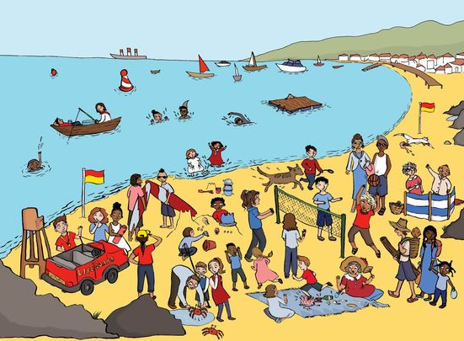

(1) a. present real: [habit]

b. Fronted:

(2) a. future real: [prediction]

b. Fronted:

(3) a. present real: [possibility]

b. Fronted:

(4) a. future real: [offer]

b. Fronted:

Part E: Unreal Conditionals [8 points]: Use the Picture I give you.
Write sentences about the picture using active, passive, and fronted conditionals


Present Unreal Simple:

(1a) Active:

(1b) Active Fronted:

(2a) Passive:

(2b) Passive Fronted:

Past Unreal Continuous:

(3a) Active:

(3b) Active Fronted:
(4b) Passive:

(4c) Passive Fronted:

Part F [3 points] Make a sentence with a direct object noun clause for each of the following noun clause words:

(1) [when]

(2) [which]

(3) [if]

Part G [3 points] Make a sentence with a subject noun clause for each of the following noun clause words.

(1) [what]

(2) [that]
(3) [whether]

Picture for Part H, Part I


https://www.pinterest.com/keledakit/busy-pictures/
Part H: Active Adverbial Clauses [4 points] Write 2 sentences with the 2 subordinators below. Then reduce them. (Use the Picture I give you.)

(1) [Before]

- full form:

- reduced:

(2) [While]

a. full form:

- reduced:
Part I: Passive Adverbial Clauses [4 points] Write 2 sentences with the 2 subordinators below. Then reduce them. (Use the Picture I give you.)

(1) [once]

- full form:

- reduced:

(2) [since]

a. full form:

- reduced:

Part J: Passive Tense [8 points] Write 8 passive sentences with the 8 words below. Use each of the 8 verb tense forms below at least once in your 8 sentences.
Present: Future:
-simple present -simple future
-present continuous -future continuous
-present perfect -future perfect
-present perfect continuous -future perfect continuous
____________________________________________________________________________________
1) sleep

2) look for

3) apologize
4) go

5) work

6) speak

7) spend

8) travel

Part K: Verb Tenses (6 points)
Start a short story in the past, then move to the present, and finish it in the future. Use the story guide below:
- Last month, Alex decided to move to the United States…
Use each of the following verb tense forms (1/2 point each):
simple past simple present simple future
past continuous present continuous future continuous
past perfect present perfect future perfect
past perfect continuous present perfect continuous future perfect continuous
______________________________________________________________________________

