Use the picture below to answer Parts A, B, and C
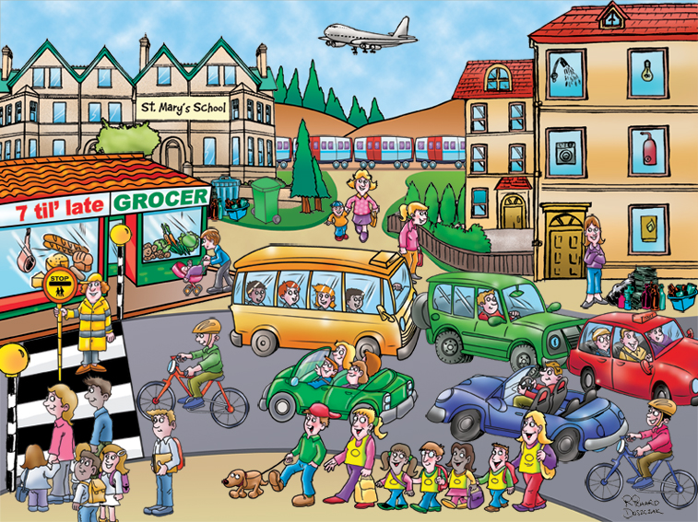
Part A: Active Adjective Clauses (5 pts., 1pt. for each sentence)
Write & reduce subject-subject, object-subject adjective clause sentences. Underline the adjective clauses.
1. Subject-Subject: [Who]

reduced:

2. Object-Subject: [That]

reduced:

fronted:

Part B: Reduced & Fronted Subject-Object Clauses (8 pts., 1 pt. for each sentence)
Write 1 active subject-object sentence. Then use passive, reduced, and fronted for each one.
1. Subject-Object: [Which]

passive:
reduced:

fronted:

2. Subject-Object: [Where]

passive:

reduced:

fronted:

Part C: Reduced & Fronted Object-Object Clauses (4 pts., 1 pt. for each sentence)
Write 1 active object-object sentence. Then use passive, reduced, and fronted for each one.
1. Object-Object: [Which]

passive:

reduced:

fronted:

Use the picture below to answer Parts D & E
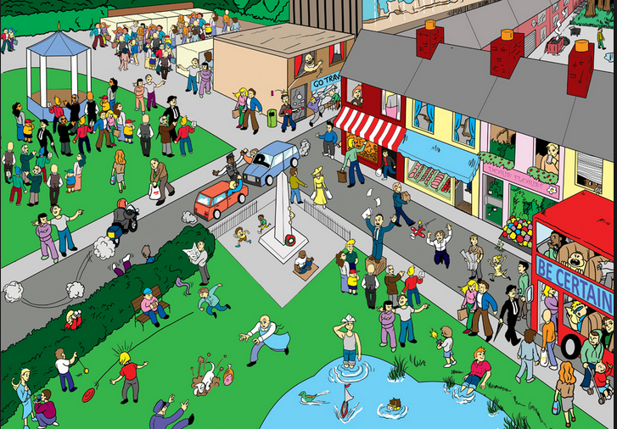
Part D: Active Adverbial Clauses (4 pts., 1 pt. for each sentence)
Write 2 sentences with the 2 subordinators below. Then, reduce them.
1. [before]

reduced:

2. [while]

reduced:

Part E: Passive Adverbial Clauses (4 pts., 1 pt. for each sentence)
Write 2 sentences with the two subordinators below. Then, reduce them.
1. [once]

reduced:

2. [since]

reduced:

Use the picture below to answer Part F
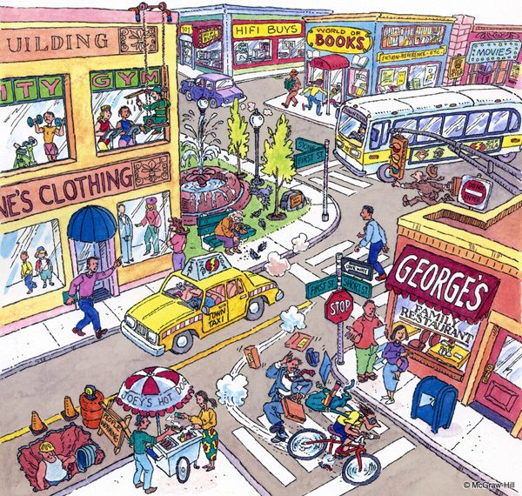
Part F: Conditionals (4 pts., 1 pt. for each sentence)
Write conditional sentences about anything in the picture.
1. Present Real: [habit]
fronted:

2. Future Real: [prediction]
fronted:

3. Present Real: [possibility]
fronted:

4. Future Real: [offer]
fronted:

Use the pictures below to answer Part G
Part G: Unreal Conditionals [8 pts., 1 pt. for each sentence]
Write sentences about the picture using active, passive, and fronted conditionals.
Present Unreal Simple:
1a. Active:

1b. Active Fronted:

2a: Passive:

2b.: Passive Fronted:

Passive Unreal Continuous
3a.: Active:

3b. Active Fronted:

4a. Passive:

4b. Passive Fronted:

Part H (3 pts., 1 pt. for each sentence)
Make a sentence with a direct object noun clause for each of the following noun clause words
1. [when]

2. [which]

3. [if]

Part I (3 pts., 1 pt. for each sentence)
Make a sentence with a subject noun clause for each of the following noun clause words.
1. [what]

2. [that]

3. [whether]

Part J: Passive Tense (8 pts., 1 pt. for each sentence)
Write 8 passive sentences with the 8 words below. Use a different verb tense from the list below for each of your 8 sentences.
Present: Future:
-simple present -simple future
-present continuous -future continuous
-present perfect -future perfect
-present perfect continuous -future perfect continuous

1. go

2. buy

3. travel

4. leave

5. make

6. send

7. find

8. sit

Part K: (12 pts.)
Start a short story in the past, then move to the present, and finish it in the future. Use the story guide below:
Last week, Roy got lost in New York City ……..
Use each of the following verb tense forms:
simple past x 1 simple present x 1 simple future x 1
past continuous x 1 present continuous x 1 future continuous x 1
past perfect x 1 present perfect x 1 future perfect x 1
past perfect continuous x 1 present perfect continuous x 1 future perfect continuous x 1

____________________________________________________________________________________________________________________________________________________________________________________________________________________________________________________________________________________________________________________________________________________________________________________________________________________________________________________________________________________________________________________________________________________________________________________________________________________________________________________________________________________________________________________________________________________________________________________________________________________________________________________________________________________________________________________________________________________________________________________________________________________________________________________________________________________________________________________________________________________________________________________________________________________________________________________________________________________________________________________________________________________________________________________________________________________________________________________________________________________________________________________________________________________________________________________________________________________________________________________________________________________________________________________________________________________________________________________________________________________________________________________________________________________________________________________________________________________________________________________________________________________________________________________________________________________________________________________________________________________________________________________________________________________________________________________________________________________________________________________________________________________________________________________________________________________________________________________________________________________________________________________________________________________________________________________________________________

