Part 1: Fact or Opinion (5 points)
Listen to the sentences from the lecture. If the sentence is a fact, write F. If the sentence is an opinion, write O.

- __________________
- __________________
- __________________
- __________________
- __________________

Part 2: Making Predictions (2 points)
In this lecture, you will hear a discussion about the question “Should the Inuit people of North America hunt seals?” What are two things you predict you might learn in this lecture?

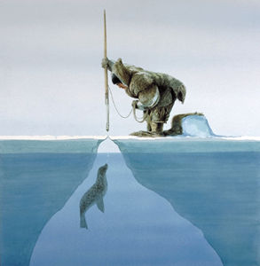
Part 2A: Notetaking (0 points)
You will hear a lecture about the Inuit people and seal hunting. Take notes on this page as you listen using key words, abbreviations, symbols and acronyms.

Part 2B: Notetaking Abbreviations and Symbols (2.5 points)
What do each of the following symbols and abbreviations mean?

1. | ex |  | 6. | #
2. | > |  | 7.
3. | w/o |  | 8. | =
4. |  |  | 9. | k
5. | % |  | 10. | ~

Part 3: Short Answers (10 points)
Use your notes to answer these questions.
Comprehension:
1. How do people kill seals?

2. Why do the Inuit people kill seals?

3. The Inuit people compare killing seals to European people killing animals such as
____________ or ______________ .

4. What part of a seal do the Inuit people use?

5. Where do the Inuit people want to sell seal products?

Inference: (4 points)
- Why can’t the Inuit people grow food like rice or wheat?

- Why does the professor ask the class, “How many people in this class eat animal products like meat or eggs?”

Vocabulary: (2 points)

1. What does the word hunt mean?

Use the word hunt in your own sentence.

