Part 1: Fact or Opinion (5 points)
Listen to the sentences from the lecture. If the sentence is a fact, write F. If the sentence is an opinion, write O.

1. _______________ 4. ________________
2. _______________ 5. ________________
3. _______________
Part 2: Making Predictions (2 points)
You will hear a lecture about the topic, “The Life and Work of Nikola Tesla.” What are two things you might learn in this lecture?
1.

2.

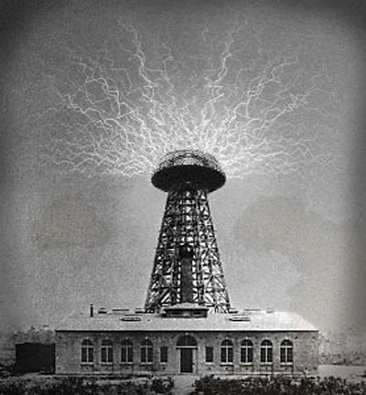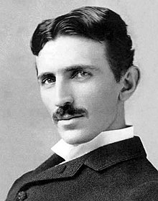
Part 2A: Notetaking
You will hear a lecture about the life and work of Nikola Tesla. Take notes on this page as you listen using key words, abbreviations, symbols, and acronyms.

Part 2B: Notetaking Abbreviations and Symbols (5 points)
What do each of the following symbols and abbreviations mean?
1. | i.e. |  | 6. | #
2. | > |  | 7. | +
3. | w/o |  | 8. | e.g.
4. | % |  | 9. | s/o
5. | avg. |  | 10. | ~

Part 3: Short Answers (8 points)
Use your notes to answer these questions.
1. What is one thing that Tesla helped develop?

2. What type of science did Tesla work with the most?

3. Why was Tesla very poor when he died?

4. One of Tesla’s biggest contributions was showing how __________________ could travel safely between two things.
5. How did Tesla show an example of remote control technology?

6. Where did Tesla first find work when he came to America?

7. How might things be different today without the inventions of Nikola Tesla?

8. What does the word weapon mean?

