Part 1: Fact or Opinion (5 points)
Listen to the sentences from the lecture. If the sentence is a face, write F. If the sentence is an opinion, write O.
1. ________ 2. ________ 3. ________ 4. ________ 5. ________
Sentences
1. African elephants are cuter than Asian elephants. (O)
2. People should not be allowed to ride elephants. (O)
3. Elephants drink about 50 gallons of water each day. (F)
4. According to the lecture, people can teach elephants to do tricks. (F)
5. Training elephants to do tricks is a waste of time. (O)
Part 2: Making Predictions (2 points)
In this lecture, you will hear about Asian elephants and African elephants. What are two things you think you will learn in this lecture? Please answer in complete sentences.
1. Any reasonable: .5 pts for complete sentence, .5 points for content
2. Any reasonable: .5 points for complete sentence, .5 points for content
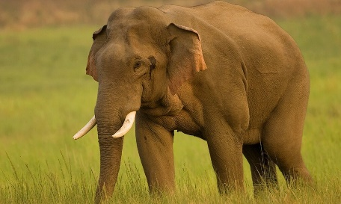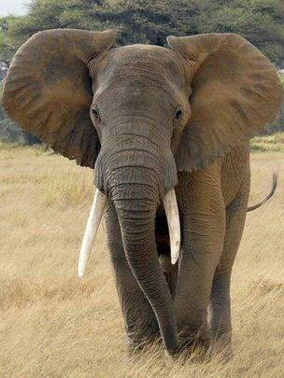
Notetaking
You will hear a lecture about Asian elephants and African elephants. Take notes on this page as you listen. Use keywords, symbols, and acronyms.
Notetaking is not graded. Students should take notes in class, return them to the teacher, and take the listening diagnostic the next day. Students can use their notes on the listening diagnostic.
Part 3: Short Answers (13 points)
Use your notes – ONLY your notes – to answer these questions.
1. What are three ways Asian elephants and African elephants are similar?
Any three of: big; use trunks to eat/ drink/ pick things up; intelligent; can do heavy work; can do tricks/ entertain; fascinating (1 point each)
2. What are three ways Asian elephants and African elephants are different?
Any three of: height; weight; ear size; tusks; color; temperament (1 point each)
3. Why do people usually see Asian elephants in circus shows?
They are easier to tame (1 point)
4. How much taller is an African elephant, compared to an Asian elephant?
African elephants are around three feet taller than Asian elephants (1 point)
5. Not all Asian elephants have _____________________________.
tusks (1 point)
6. Which kind of elephant is better for doing heavy work? Why? Use examples from your notes.
Option 1: Asian elephants (.5 points), because they are easier to train/ tamer (.5 points)
Option 2: African elephants (.5 points), because they are larger (.5 points)
7. What might happen if an elephant lost its trunk? Use examples from your notes in your answer.
The might not be able to (one of the following) eat, drink, or lift things (1 point)
8. What does the word wild mean?
Lives in nature; does not live with humans (1 point)

Note: - .5 points for information that was not from the notes

