Part 1: Fact or Opinion (5 points)
Listen to the sentences from the lecture. If the sentence is a fact, write F. If the sentence is an opinion, write O.
1. ________ 2. ________ 3. ________ 4. ________ 5. ________
Part 2: Making Predictions (2 points)
In this lecture, you will hear about Asian elephants and African elephants. What are two things you think you will learn in this lecture? Write complete sentences.
1.

2.

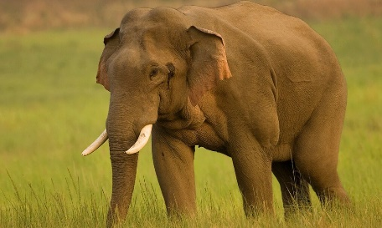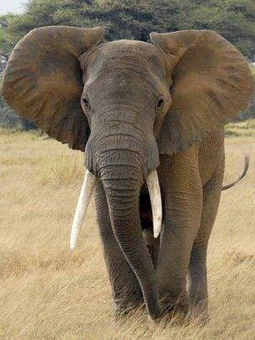
Notetaking
You will hear a lecture about Asian elephants and African elephants. Take notes on this page as you listen. Use keywords, symbols, and acronyms.
Part 3: Short Answers (13 points)
Use your notes – ONLY your notes – to answer these questions.
1. What are three ways Asian elephants and African elephants are similar?

2. What are three ways Asian elephants and African elephants are different?

3. Why do people usually see Asian elephants in circus shows?

4. How much taller is an African elephant, compared to an Asian elephant?

5. Not all Asian elephants have _____________________________.

6. Which kind of elephant is better for doing heavy work? Why? Use examples from your notes.

7. What might happen if an elephant lost its trunk? Use examples from your notes.

8. What does the word wild mean?

