Teacher Script and Answer Key

Part A: Dictation
Directions: You will hear each sentence two times. Write the sentence exactly how you hear it.
- Hidden cameras can capture images of the animals in their natural habitat.
- The objective of the new law is to reduce wildlife trafficking.
- Poaching, or the illegal hunting of wild animals, is one of the biggest threats to larger animals such as elephants.
Part B: Vocabulary Inference
Directions: Listen to excerpts of the talk and write the meaning of each phrase. You will hear each excerpt two times.

- "But unfortunately, these animals are under constant threat from poachers who hunt and kill them for their body parts."
- "Not only does a drone give you a bird's-eye view of the landscape, but it also allows you to capture detailed, high-resolution images of objects on the ground."
- "But drones could also be used to keep track of illegal logging activities."
- "Now as you can imagine, that is a very time-consuming, labor-intensive, and costly process, so we were hoping that drones could significantly reduce the cost of surveying for orangutan populations in Indonesia and elsewhere in Southeast Asia."

Part C: Instruct students to preview the questions (5 minutes). Instruct students to take notes in part C. Their notes are graded. After taking notes, they will answer the comprehension questions. Play edited TEDTalk two times (track 37 on the flash drive for 21st Century Communication Book 2). 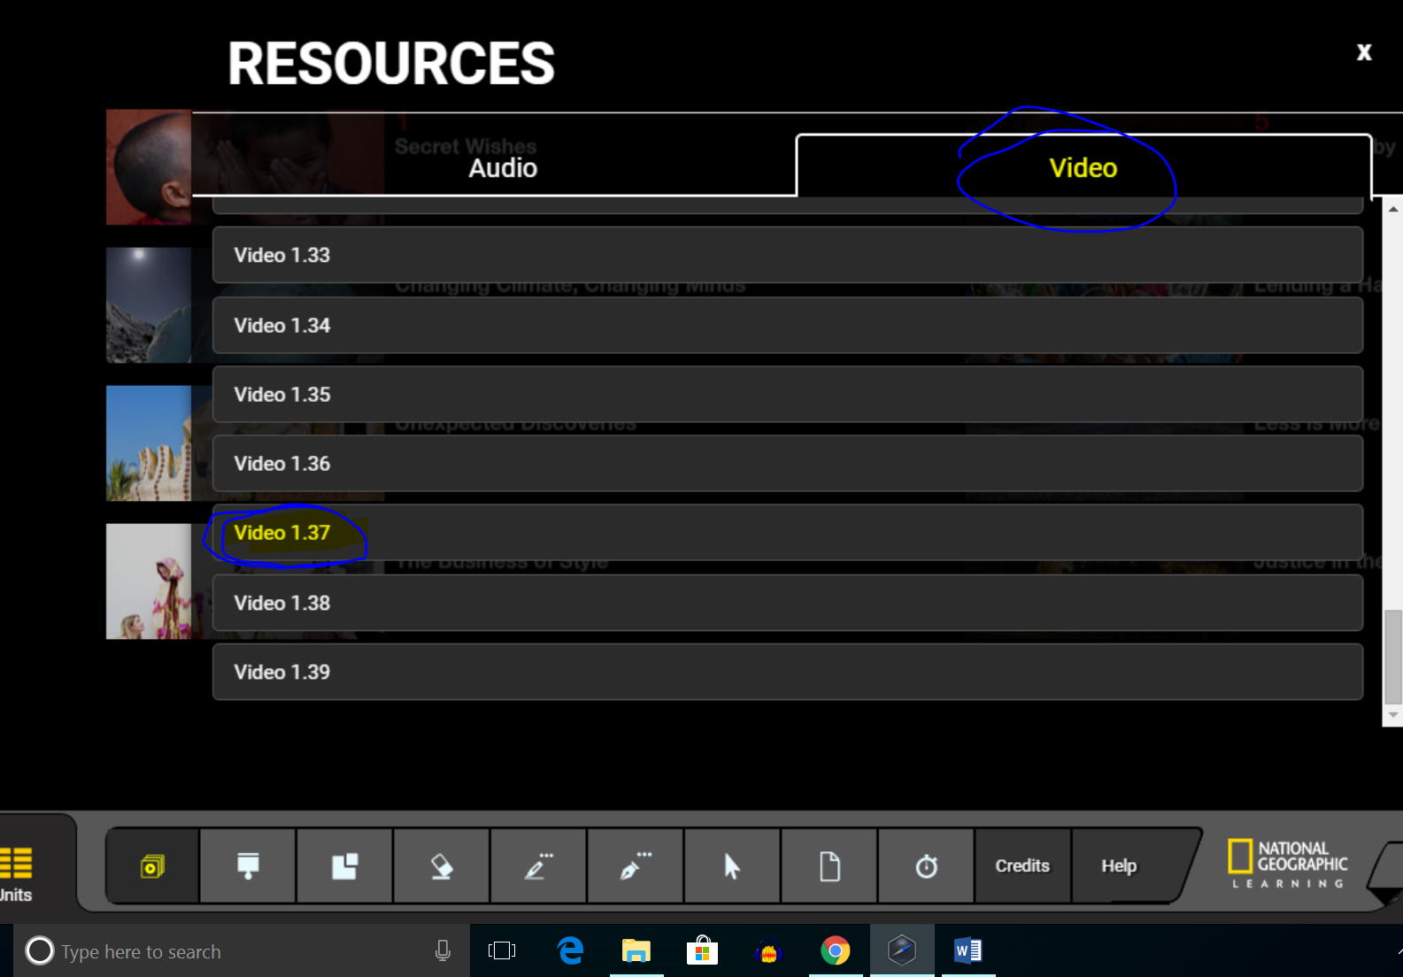
If for some reason, you cannot play this track, play this: https://www.ted.com/talks/lian_pin_koh_a_drone_s_eye_view_of_conservation#t-480080. (00-2:10, then skip to 4:26-8:03)

STUDENT EXAM ANSWER KEY

Score _____ out of 40 points possible
Part A: Dictation [2 points each = 6 points]
Directions: You will hear each sentence two times. Write the sentence exactly how you hear it.
Answers: See Teacher Script
- __________________________________________________________________________________________________________________________________________
- __________________________________________________________________________________________________________________________________________
- __________________________________________________________________________________________________________________________________________
Part B: Vocabulary Inference [1 point each = 4 points]
Directions: Listen to excerpts of the talk and write the meaning or a synonym for each phrase. You will hear each excerpt twice.
- What is the meaning of “under threat”?
  - In danger
- What is the meaning of “a bird’s-eye view”?
  - Seen from above
- What is the meaning of “keep track of”?
  - Watch carefully, monitor
- What is the meaning of “labor-intensive”?
  - Difficult because it requires a lot of work or detail

Part C: Note-taking
Directions: Before watching, read the questions on the next pages. You will watch a TEDtalk. Take notes in the space below. Check your notes for their content, organization and your use of keywords, symbols, and abbreviations.

Part D: Listening Comprehension [2 points each = 18 points]
Directions: Use your notes to help you answer all of these questions.
- What is the main idea of the talk?
-Drones can be used effectively to help conservation of forests and animals.
- According to the talk, what were two major uses for drones in conservation?
-to combat wildlife crime such as poaching
-monitor the health of wildlife populations
-monitor animals’ habitat
-monitor land use and encroachment on habitat

- According to the talk, what was one reason that scientists want to use drones to monitor orangutans in the forests?
-Significantly reduce the cost of surveying the population
-Monitoring the health of their habitats

- According to the talk, what are two advantages of creating detailed maps?
-monitor land use changes
-watch for forest fires
-create 3D maps to monitor the health of forests
-Scientists can study the forests in more detail

- Give an example of a fact or statistic from this talk.

- Based on the talk, would the speaker agree or disagree with this statement? Why?
  - “I want to make a lot of money by building drones and selling them to scientists.”

- Do you think conservation drones will be more successful than traditional methods in combatting wildlife crime? Why or why not?

- What might be some challenges in using conservation drones? Explain your answer.

- Is animal or forest conservation a priority in your country? Why or why not?

-End of Exam-

