ELS004
Speaking Diagnostic Spring 2018
- First, students will watch this video as homework to get some background knowledge on drones: https://www.youtube.com/watch?v=YO82OxqKjUU
- Based on class size, the teacher will prepare a sign up sheet (next page).
- Upon entering the classroom for the speaking test, the student will have 5 minutes to study the infographic about drones. Then, students will choose 3 of these questions from a hat, and select two of those three to answer for the teacher. Answers should be supported with reasons and examples from the infographic and/or student’s personal knowledge. The teacher may prompt students with follow up questions.
- The speaking diagnostic will be graded based on the accuracy of the ideas/content in your answer (30%), your overall intelligibility in spoken English [including grammar, pronunciation, and volume] (30%), your use of appropriate vocabulary and words to organize your ideas (20%), and your ability to present and manage yourself professionally [e.g., body language, eye contact, referring to the chart] (20%).

- What do you think is the most important benefit of drones?
- What do you think is the most important limitation of drones?
- Of the ways that drones are changing, which change is exciting for you?
- Of the ways that drones are changing, which change is scary for you?
- Of the business applications, which would be the most helpful in your country?
- Of the business applications, which would be the least helpful in your country?
- Describe the information in the bar graph.
- In your own words, explain how drones collect data.
- Would you like to have a drone? Why or why not?
- Would you like to be a passenger in an unmanned aircraft? Why or why not?
- Do you think we should use drones in wars? Why or why not?

 | Name |  | Name
1 |  | 2
3 |  | 4
5 |  | 6
7 |  | 8
9 |  | 10
11 |  | 12
13 |  | 14
15 |  | 16
17 |  | 18
19 |  | 20

After signing up, all students will wait outside the classroom. Student 1 will enter the classroom first, and have 5 minutes to study the infographic. After those 5 minutes, student 2 will enter and begin looking at the infographic as Student 1 talks to the teacher. As student 1 leaves, he/she will inform student 3 to enter the classroom and begin looking at the infographic. This proceedure minimizes the possibility of unfair advantage, and maximizes the available class time.
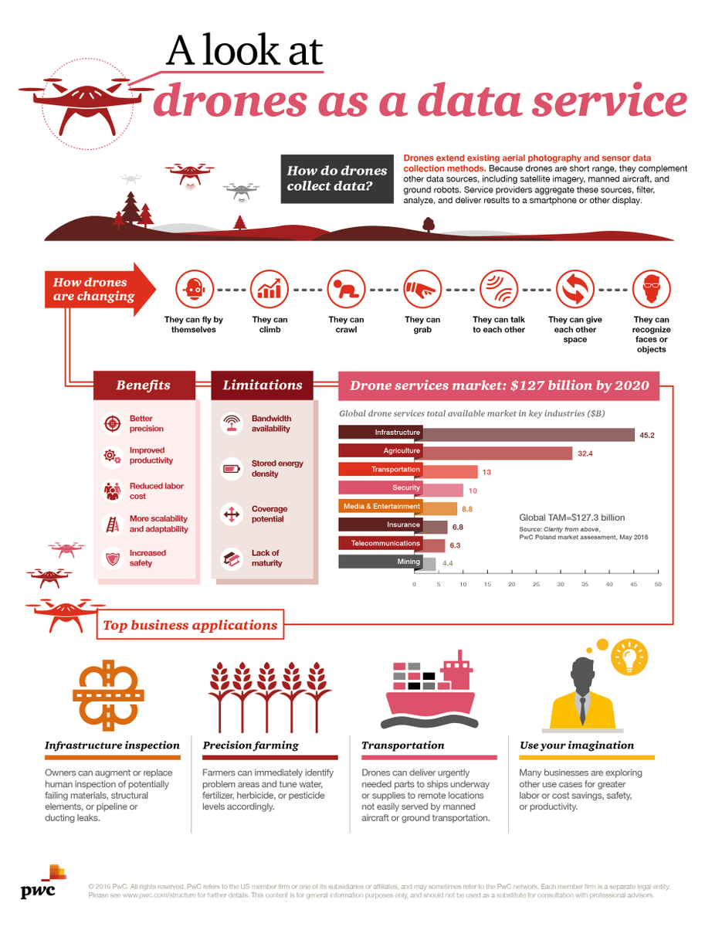
Rubric for Speaking Diagnostic
 | 10 | 7 | 5 | 3
Content
- Comprehension
- Prediction, inference, differentiation
- Organization
Intelligibility
- Pronunciation
- Grammar
- Volume
Vocabulary
- Academic
- Idiomatic
Presentation and Self-Management
- Eye contact
- Body language
- Using visual as a reference

Total ________/34 = _______%

