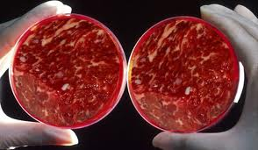
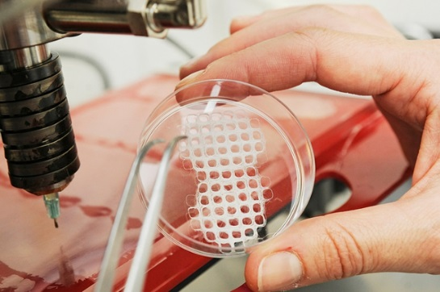
Part 1: Making Predictions (2 points)
Andrews Forgacs is a bioprinting entrepreneur. He produces animal products – meat and leather – without the animal. In this video, he will argue that biofrabricating meat and leather is a civilized way to create animal products.

What are two things you predict you might learn in this lecture?

Part 2A: Notetaking
You will hear a lecture about biofabrication. Take notes on this page as you listen using key words, abbreviations, symbols and acronyms.

Part 3: Listening Comprehension (20 points)

- What did Forgacs and his father do in their company before growing animal products? (1 point)

- Explain the graphic below shown by Forgacs in his lecture. (2 points)
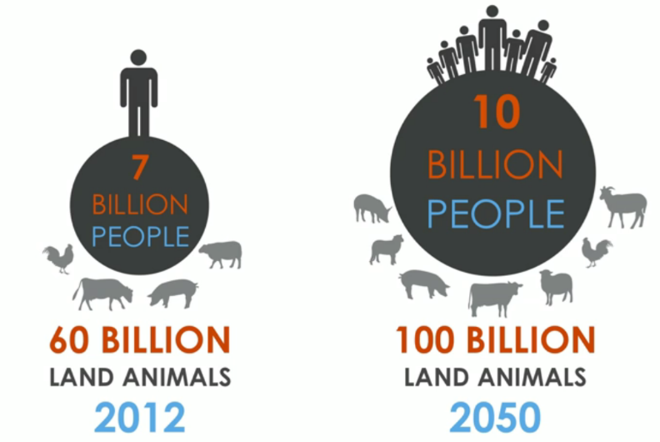

- Forgacs explains that maintaining a large number of animals “takes a toll on our planet.” What does take a toll on mean and what are two (2) examples of how large numbers of animals take a toll on our planet? (3 points)

- What is biofabrication? (2 points)

- How is biofabrication already being used today in the medical field? (2 point)

- Forgacs explains that we should begin by “reimagining leather.” What are two of the reasons why he emphasizes leather? (2 points)

- The graphic below illustrates the process of biofabrication. Explain steps 1, 3, 5, and 7. (4 points)
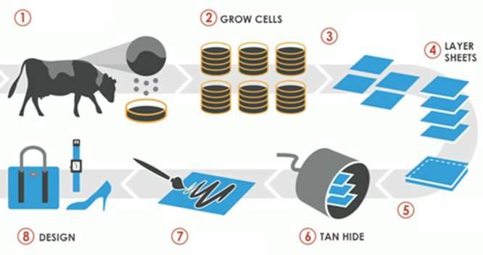
- Step 1
- Step 3
- Step 5
- Step 7
- Forgacs explans that “we grow this leather from the ground up.” What does from the ground up mean? (2 points)

- What are two of the benefits of biofabricated leather? (2 points)

- Describe the future of animal products which Forgacs imagines. (2 points)

Part 4: Stating Your Opinion (5 points)
Choose one of the statements below and write a response explaining why you agree or disagree. Use information from the lecture to support your opinion. Put a in the box of the statement you’re responding to.

- Animals are less valuable than humans, and this makes it okay to use and kill them, as long as they don’t suffer too much. Therefore there is no point in developing new technology like what Forgacs suggests– it’s a waste of time and money better spent on people.
- If this kind of technology becomes popular, then millions of people will lose their jobs as farmers and other producers of animal products. Entire populations will fall into poverty. It is therefore unethical to pursue biofabrication because of the economic harm it will do.

