Part 1: The Be Verb (12 points)
Write 3 complete sentences using the “be” verb and the information and subjects below. (3 points)

- Simple Present positive [she]
- Simple Past negative [the students]
- Simple Future positive [I]
Ask and answer 3 yes/no questions using the “be” verb in the past, present, and future tenses. (6 points)
- Past
  - Q:
A:
- Present
  - Q:
A:
- Future
  - Q:
A:
Ask 3 wh- questions using the “be” verb. (3 points)
- Past
  - Q:
- Present
  - Q:
- Future
  - Q:
Part 2A: Verb Tenses Story (6 points)
Write a story using each of the following verb tenses. Use action verbs and the story guide below:

- Last month, Tyler visited his sister in Daytona Beach.

- Use each of the following verb tense forms:

simple past simple present simple future
past continuous present continuous future continuous
______________________________________________________________________________

Part 2B: Negative Verb Tenses (7 points)
Make a negative sentence with an action verb about these people and things.

- Simple Past [Tyler]:
- Past Continuous [Jose and Tyler]:
- Simple Present [the class]:
- Present Continuous [I]:
- Present Continuous [Khalid and Alex]
- Simple Future [Tyler’s friend]:
- Future Continuous [we]

Part 3: Questions (9 points)
Write a question using the information below. Do not use the “be” verb. Use an action verb.

- Yes/No Questions
  - Simple Present
  - Past Continuous
  - Past Continuous
  - Simple Future
- Wh- Questions
  - Present Continuous [Where]
  - Simple Past [When]
  - Simple Future [How]
  - Future Continuous [What]
  - Simple Present [Why]
Part 4: Imperatives (2 points)
Write 2 sentences with Imperatives. Tell someone how to be successful.

Part 5: Phrasal Verbs: Write a sentence for each of the phrasal verbs below. [NOTE: Substitute in the verbs you covered in class]
1. hang on
2. pick up
3. run into
4. call off
5. drop off

Part 6: Modals (8 points)
Write present modal sentences about the picture below.
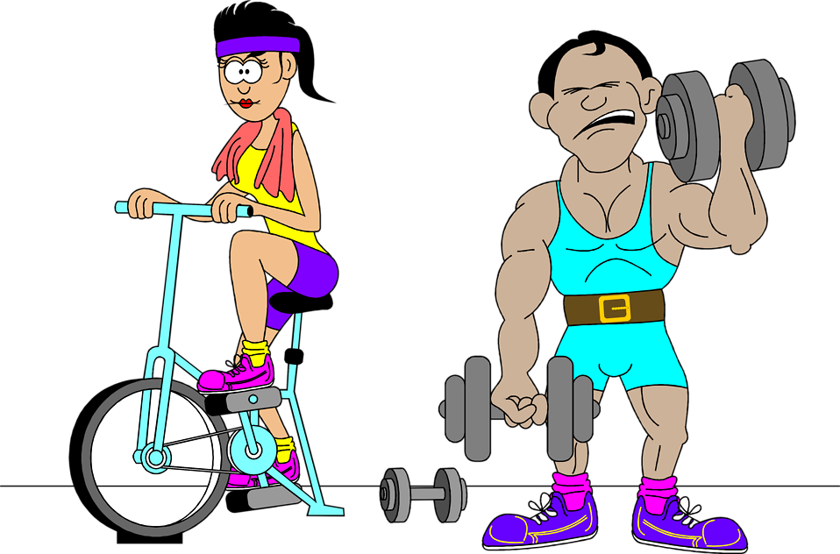

Simple Present Modals (Statements)
- must (guess)

- would

Simple Present Modals (Questions)
- should

- can

Present Continuous Modals (Statements)
- ought to

- might

Present Continuous Modals (Questions)
- could

- must

Part 7: Adjectives and Adverbs (10 points)

Adverbs of Frequency – Use a different adverb of frequency in each sentence. Use the picture.

- [be verb]
Adverbs of Degree – Write a sentence using an adverb of degree. Use the picture.

Adverbs to Describe an Action – Use a different adverb in each sentence. Use the picture.

Adjectives to Describe Nouns - Use a different adjective in each sentence. Use the picture.

Comparative Adjectives – Use adjectives to write sentences using the comparative. Use the adjective given. Use the picture.
- big
- happy
Superlative Adjectives – Use adjectives to write sentences using the superlative. Use the adjective given. Use the picture.
- good
- busy
Part 7: Nouns (6 points)

Use the picture to write sentences using the words below and a noun in the picture.
1. A lot of
2. Some
3. A few
4. A little
5. Question: many
6. Question: much
Part 8: Adverb Clauses: (2 points) Write sentence with each of the adverb clause words below:
1. When

2. Because

