Part 1: The Be Verb (13 points)
Write 3 complete sentences using the “be” verb and the information and subjects below. (4 points)

- Simple Present negative [she]
- Simple Past negative [the students]
- Simple Future (will) positive [I]
- Simple Future (be going to) negative [Tariq]
Ask and answer 3 yes/no questions using the “be” verb in the past, present, and future tenses. (6 points)
- Past
  - Q:
A:
- Present
  - Q:
A:
- Future
  - Q:
A:
Ask 3 Wh- questions using the “be” verb. (3 points)
- Past
  - Q:
- Present
  - Q:
- Future (will)
  - Q:
Part 2A: Verb Tenses Story (6 points)
Write a short story using each of the following verb tenses. Use action verbs and the story guide below:

- Last month, Jason visited his brother in Daytona Beach.

Use each of the following verb tense forms:

simple past simple present simple future
past continuous present continuous future continuous
______________________________________________________________________________

Part 2B: Negative Verb Tenses (8 points)
Make negative sentences with an action verb about the indicated people and things.

- Simple Past [Tyler]:
- Past Continuous [Joseph and Diana]:
- Simple Present [the class]:
- Present Continuous [I]:
- Present Continuous [Karen and Abdullah]
- Simple Future (will) [Ken’s friend]:
- Simple Future (be going to) [Hashem’s cousin]:
- Future Continuous [we]

Part 3: Questions (10 points)
Write questions using the information below. Use an action verb!

- Yes/No Questions
  - Simple Present
  - Present Continuous
  - Simple Past
  - Past Continuous
  - Simple Future
- Wh- Questions
  - Simple Present [Why]
  - Present Continuous [Where]
  - Simple Past [When]
  - Simple Future [How]
  - Future Continuous [What]
Part 4: Imperatives (2 points)
Write 2 sentences with Imperatives. Tell someone how to be successful.

  - (positive)

  - (negative)

Part 5: Modals (8 points)
Write present modal sentences about the picture below.
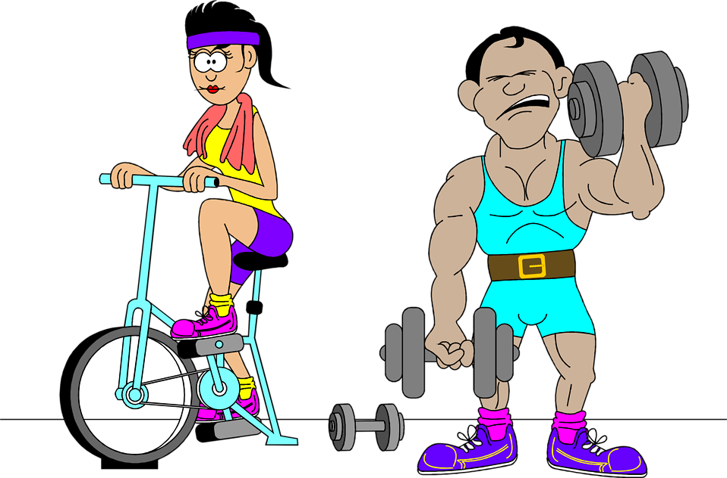

Simple Present Modals (Statements)
- must (guess)

- might (guess)

Simple Present Modals (Questions)
- could (permission)

- would (polite request)

Present Continuous Modals (Statements)
- should

- might

Present Continuous Modals (Questions)
- could

- must

Part 6: Adjectives and Adverbs (9 points)

Adverbs of Frequency – Write 2 sentences using Adverbs of Frequency. Use a different adverb in each sentence. Use the pictures.
- [action verb]
- [“be” verb]
Adverbs of Intensity – Write a sentence using an Adverb of Intensity. Use one of the pictures.

Adverbs of Manner (to Describe an Action) – Write 2 sentences using Adverbs of Manner. Use a different adverb in each sentence. Use the pictures.

Comparative Adjectives – Use the following adjectives and the pictures above to write sentences using the comparative.
- generous
- happy
Superlative Adjectives – Use the following adjectives and the pictures above to write sentences using the superlative.
- short
- talkative
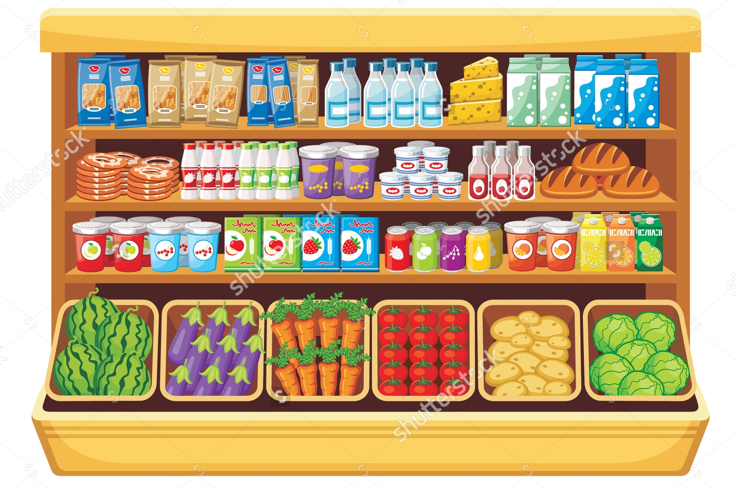
Part 7: Nouns (8 points)
Use the picture to write sentences using the words below and a noun in the picture.
- A lot of
- Some
- A few
- A little
- Question: many
- Question: much
- A head of
- A loaf of
Part 8: Phrasal Verbs: Write a sentence for each of the phrasal verbs below. [NOTE: Substitute in the verbs you covered in class]

1. hang on
2. pick up
3. run into
4. call off
5. drop off
Part 9: Adverb Clauses: (2 points) Write sentence with each of the adverb clause words below:
1. When

2. Because

