Directions: Use these pictures for EACH part of the test. Here are some useful vocabulary words.
airport | take off | wait | passenger | fuel
smoke | land | crew | pilot | put on
truck | check | flight attendant | seat belt | luggage
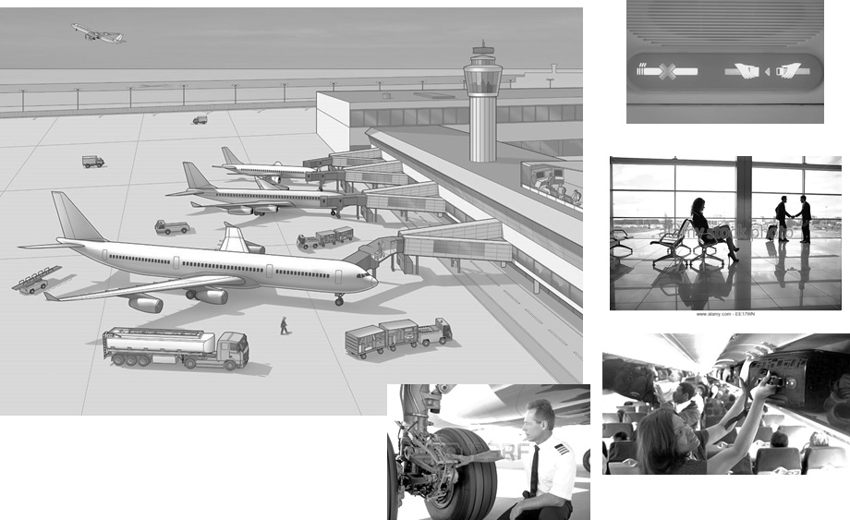

Part 1: The Be Verb (12 points)
Write 4 complete sentences about the pictures using the “be” verb. (4 points)

- Simple Present positive
- Simple Past negative
- Simple Future positive
- Simple Present negative
Write 4 questions and 4 answers about the pictures using the “be” verb. (8 points)

- Simple Present + “be” verb
  - Yes/No Question:
- Yes/No Answer:
- Wh- Question:
- Wh- Answer:

- Simple Past + “be” verb
- Yes/No Question:
- Yes/No Answer:
- Wh- Question:
- Wh- Answer:

Part 2: Verb Tenses (6 points)

7. Start a short story in the past, move to the present, and then the future. Use the story guide below:

- Use all of the following verb tense forms:

simple past simple present simple future
past continuous present continuous future continuous

Last month, I was at the airport.

______________________________________________________________________________________________________________________________________________________________________________________________________________________________________________________________________________________________________
____________________________________________________________________________________________________________________________________________________________________________________________________
________________________________________________________________________________________________________________________________________________________________________________________________________________________________________________________________________________________________________________________________________________________________________________________________________
____________________________________________________________________________________________________________________________________________________________________________________________________

Part 3: Questions (6 points)
Write questions about the pictures. Use an action verb. Don’t use “be” as the main verb.

- Yes/No Questions
  - Simple present
  - Simple past
  - Past continuous
- Wh- Questions
  - Present Continuous [How]
  - Past Continuous [What]
  - Simple Future [When]

Part 4: Imperatives (2 points)
Write 2 sentences with Imperatives. Tell someone in the pictures what to do.

Part 5: Modals (4 points)
Write four present modal sentences about the pictures.

  - Can (simple present)
  - Should (present continuous)
  - Must (simple present)
  - could (question)
Part 6: Adjectives and Adverbs (6 points)
Write three sentences using these adjectives to compare (more or –er) any people or things in the pictures.
  - [clean]
  - [busy]
  - [difficult]
Write three sentences using these adverbs about any person or thing in the picture.

- [always]
- [quickly]
- [carefully]

Part 7: Phrasal Verbs: Write a sentence for each of the phrasal verbs below. [NOTE: Substitute in the verbs you covered in class]

1. hang on

2. pick up
3. run into
4. call off
5. drop off
Part 8: Adverb Clauses: (2 points) Write sentence with each of the adverb clause words below:
1. Before

2. Because

END OF EXAM – Check your work carefully

