Name: EGM002 Final Test
Out of 78 points

Part A: The to Be Verb
- Write three complete sentences using the to be verb and the information below. Each sentence must use a different subject.
  - Present Simple/negative (1 point)
[Nasser]
  - Past Simple / negative (1 point)
[Students]
  - Future Simple/ positive (1 point)
[Heejoo]

- Write yes/no questions using the to be verb and provide an answer. Use the provided picture.
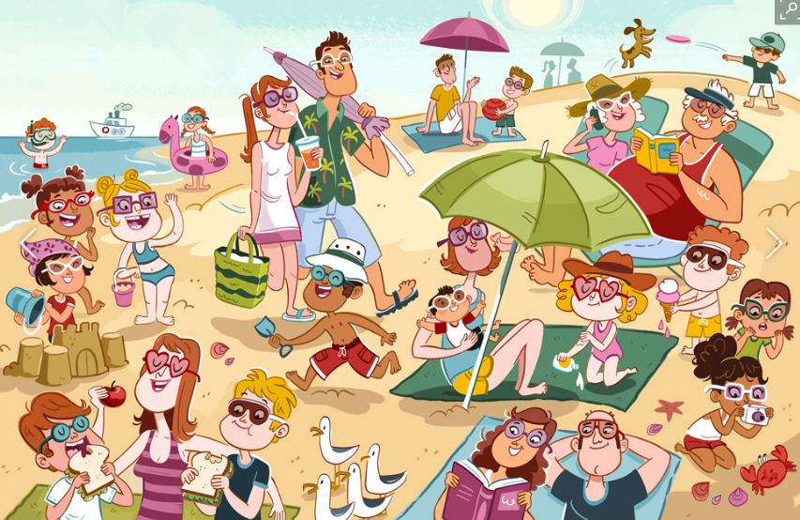
  - Present Simple (2 points)
    - Question: [The lady]
    - Answer:

  - Past Simple (2 points)
    - Question: [Kids]
    - Answer:

  - Future Simple (2 points)
    - Question: [Dad]
    - Answer:
- Write Wh -questions using the to be verb and provide an answer. Use the picture below.
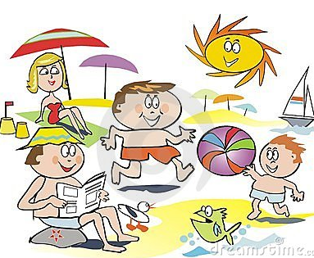
http://www.dreamstime.com/stock-photo-fun-family-beach-cartoon-image12293130
  - Present Simple (2 points)
    - Question: [woman]
    - Answer:
  - Past Simple (2 points)
    - Question: [Yazeed and Majeed]
    - Answer:
  - Future Simple (2 points)
    - Question: [You]
    - Answer:

Part B: Tenses with Action verbs (out of 24 points) Continue my short story in the past and then move to the present and then the future. Use Action Verbs. Use the story guide below:

Use each of the following verb tense forms:

simple past (2+/2-) simple present(2+/2-) simple future(2+/2-)
past continuous(2+/2-) present continuous(2+/2-) future continuous(2+/2-)
______________________________________________________________________________
Two week ago, Nawaf decided to go to college.

Now,

In 10 years,

Ask questions about the picture and give the answers.
- Write a yes/no question using the Simple Present with an action verb. (2 points)
Question: [he]
Answer:
- Write a WH-question using the Simple Present with an action verb. (2 points)
Question: [A dog]
Answer:
- Write a WH-question using the Present Continuous with an action verb. (2 points)
Question: [they]
Answer:
- Write a yes/no question using the Present Continuous with an action verb. (2 points)
Question: [A girl]
Answer:
- Write a yes/no question using the Past Simple with an action verb. (2 points)
Question: [kids]
Answer:
- Write a WH-question using the Past Simple with an action verb. (2 points)
Question: [Hussain]
Answer:
- Write a WH-question using the Past Continuous with an action verb. (2 points)
Question: [Abdulaziz and Ayman]
Answer:
- Write a yes/no question using the Past Continuous with an action verb. (2 points)
Question: [A man]
Answer:
- Write a WH-question using the Future Simple with an action verb. (2 points)
Question: [Nasser]
Answer:
- Write a yes/no question the Future Continuous with an action verb. (2 points)
Question: [It]
Answer:

Part C: Imperatives. Your friend is failing his classes. Tell him what he should and should not do. Use imperative sentences.

- (1 point) Positive
- (1 point) Negative
- (1 point) Positive
- (1 point) Negative
Part: D Adjectives and Adverbs
- Write separate sentences with adjectives about the picture
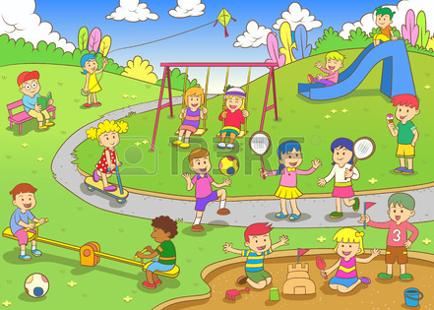
http://imgtagram.com/rewtoc2d-cartoon-kids-playing-at-the-park/

- (1 point) (Use superlative)

- (1 point) (Use comparative)

- (1 point) (adjective)

B. Write 3 sentences with the following adverbs:
1. (angrily) (1 point)

2. (daily) (1 point)

3. (never) (1 point)

Part E: Present Modals Write 3 present modal sentences telling about the things in the picture.

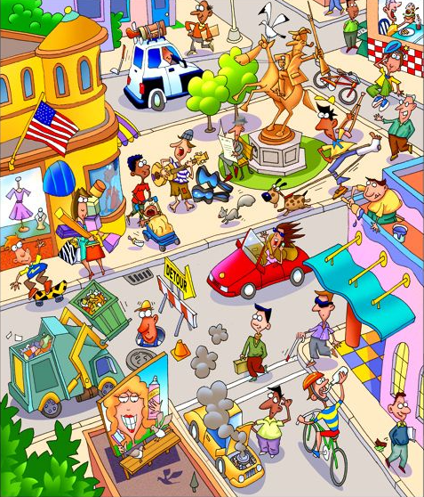

1. present simple: [advice] (negative) (1 point)
2. present simple: [possibility] (positive) (1 point)
3. present continuous: [question] (1 point)
4. present continuous: [guess] (positive) (1 point)
Part F: Phrasal Verbs: Write a sentence for each of the phrasal verbs below. [NOTE: Substitute in the verbs you covered in class]
1. hang on
2. pick up
3. run into
4. call off
5. drop off
Part G: Adverb Clauses: (2 points) Write sentence with each of the adverb clause words below:
1. Before

2. Because

