Embry-Riddle Language Institute ____ Grammar 003

Final Exam [50 points]
Part A: [12 points]
Write about your life. What did you do in the past? What are you doing now? What will you do in the future? Start your short story in the past and then move to the present and then the future.

Use each of the following verb tense forms:
simple past simple present simple future
past continuous present continuous future continuous
past perfect present perfect future perfect
past perfect continuous present perfect continuous future perfect continuous

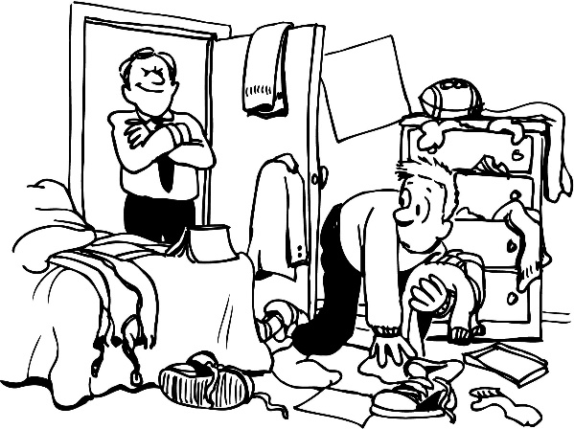
Part C: Present Modals [5 points] Write 5 present modal sentences telling me about the things in the picture.
1. present simple: [advice]
2. present simple: [possibility]
3. present simple: [question]
4. present continuous: [guess]
5. present continuous: [“had better”]
Part D: Past Modals [2 points] Use a past modal to make sentences.

- Advice about unreal past action

- Assumption about past action

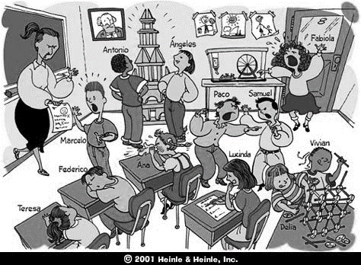
Part E: Gerunds & Infinitives [8 points total] Use the Picture and…Use the verbs/adjective below to write 8 sentences about that picture. Put a gerund or infinitive after each verb or adjective: avoid / agree / discuss / enjoy / refuse / doesn’t mind / sad about / invite

1.
2.
3.
4.
5.
6.
7.
8.
Gerund and Infinitive Subjects: [2 points] Use the phrases below as subjects in a sentence.

9. [To eat pizza]
10. [Texting and driving]
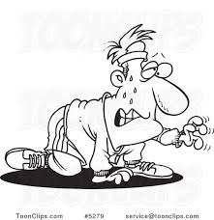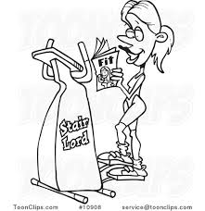
Part F: Adverb Clauses: [9 points] Use the pictures I gave you to write a sentence for each adverb subordinator.

Reason:

(1) [because]

Time:

(2) [while]

(3) [since]

(4) [until]

(5) [before]
Contrast:

(6) [whereas]

Unexpected Result:

(7) [although]

Condition:

(8) [whether]

(9) [in case]

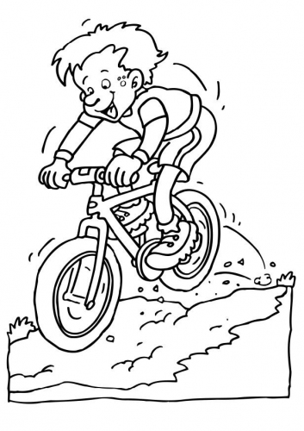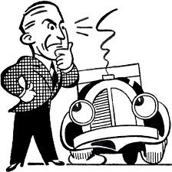
Part G: Conditionals: [6 points] Write sentences about the picture above using the clues.

- [A habit in the past]
- [A habit now]
- [A prediction for your future using “will”]
- [A prediction for your future using “might”]
- [An unreal “present” situation and the result]
- [An unreal past situation and the past result]
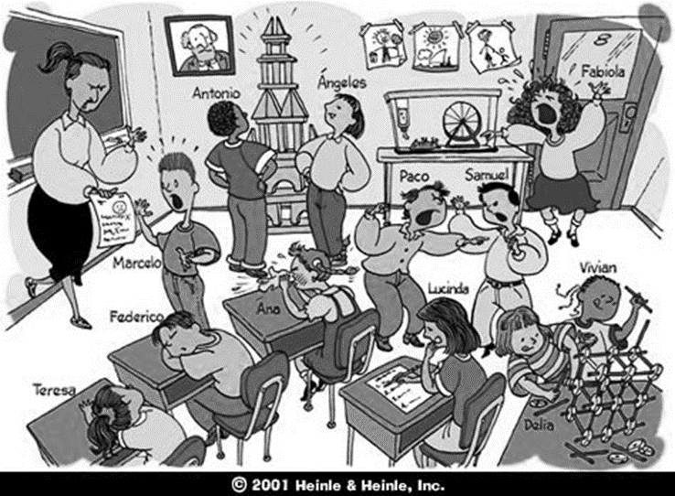
Part I: Active Adjective Clauses: [6 points] Directions: Use this picture.
- Write 6 adjective clause sentences that describe something or someone in the picture. Use the pronoun in [brackets] to start your adjective clause.
Subject –Subject:
(1) [who]
(2) [which]
Object –Subject:
(3) [which]
Object –Object:
(4) [whom]
(5) [where]
Subject –Object:
(6) [that]

