Embry-Riddle Language Institute Grammar 003

Name: ____________

Final Exam
Part A: [15 points]
Start a short story in the past and then move to the present and then the future. Use one of the story guides below:

- Last month, Jane went out for a walk…
- Two years ago, Tom met Jane…
- Three days ago, Jane got arrested…

Use each of the following verb tense forms:
simple past x 2 simple present x 2 simple future x 2
past continuous present continuous future continuous
past perfect present perfect future perfect
past perfect continuous present perfect continuous future perfect continuous

Part B: [5 points] Use the picture to write a sentence for each of the phrasal verbs below.

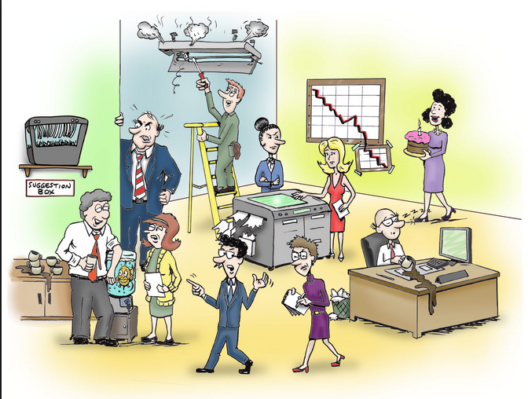

http://www.papercutsinc.com/OfficeStaff.aspx

(1) call off
(2) clean up
(3) drop by
(4) turn down
(5) hang out

Part C: Present Modals [5 points] Write 5 present modal sentences telling me about the things in the picture.
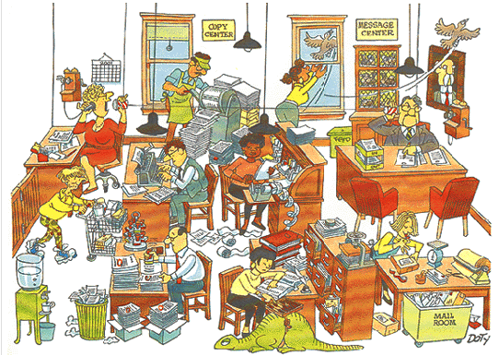
http://www.rollingalpha.com/2013/08/02/office-politics-open-offices-are-a-psychological-health-risk/
1. present simple:[advice]
2. present simple: [possibility]
3. present simple: [question]
4. present continuous: [guess]
5. present continuous: [warning]
Part D: Past Modals [4 points] In each of these situations something has happened that makes someone feel blame, warning, make a possibility or make a guess about the past. Use a past modal to make sentences.

1) Two years ago, when Tom was working in the restaurant as a waiter, he saw a beautiful girl. He decided to get to know her. He went to her table to introduce himself, but Jane told him that she did not date waiters. Now Tom is a millionaire and Jane works as a waitress…

past simple [should]:

past continuous [must]:

2) Last night, Bob got drunk and was driving home late at night. A police officer stopped him. He arrested Bob. Bob is sitting in jail now, and he is waiting for his trial.

past simple [could]:

past continuous [had better]:

Part E: Gerunds & Infinitives [10 points total] Use the Picture and…Use the verbs/adjective below to write 8 sentences about that picture. Put a gerund or infinitive after each verb or adjective: decide allow excited imagine plan remind practice permit

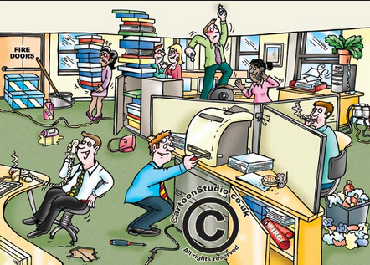
http://cartoonstudio.co.uk/cartoonist-for-hire/health-safety-cartoons-health-safety-cartoon-strips/

1.
2.
3.
4.
5.
6.
7.
8.
Gerund and Infinitive Subjects: [2 points] Use the verbs below to make subjects for a sentence.

9. [To check]
10. [Changing]
Part F: Adverb Clauses: [9 points] Use the picture I gave you to write a sentence for each adverb subordinator.
http://cartoonstudio.co.uk/cartoonist-for-hire/health-safety-cartoons-health-safety-cartoon-strips/

Reason:

(1) [because]

Time:

(2) [while]

(3) [since]

(4) [until]

(5) [by the time]

Contrast:

(6) [whereas]

Unexpected Result:

(7) [although]

Condition:

(8) [whether]

(9) [in case]

[total = 50 points]

