Part 1: Notetaking Abbreviations and Symbols (5 points)
What do each of the following symbols and abbreviations mean?

1. | ~ |  | 6. | M
2. | yr. |  | 7.
3. | w/ |  | 8. | %
4. |  |  | 9. | #
5. | > |  | 10. | ppl.

Part 2: Notetaking (6 points)
Listen to your teacher read six sentences. Write the sentences in notetaking form below. Use symbols and abbreviations.

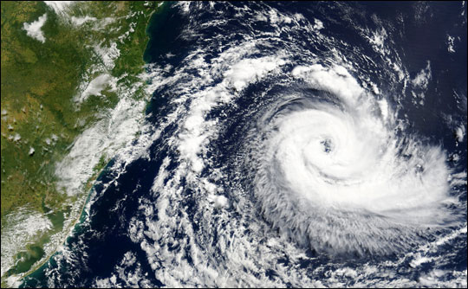
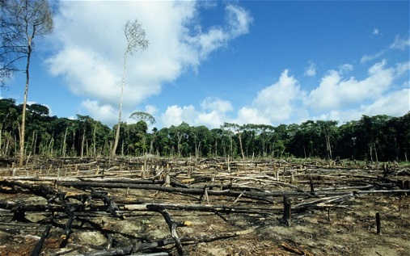

Part 3: Making Predictions (2 points)
In this lecture, you will hear a lecture called “Global Warming: Causes and Effects” What are two things you predict you might learn in this lecture?

Part 4: Lecture Notetaking
You will hear a lecture about the causes and effects of global warming. Take notes on this page as you listen using key words, abbreviations, and symbols.

Part 4: Short Answer (14 points)
Use your notes to answer these questions.

- Write the two causes and the two effects of global warming below.

- What is global warming?
- What are fossil fuels?
- What is one example of how humans use fossil fuels?
- What is deforestation?
- What is one cause of deforestation?
- Why are trees important for the world?
- How will storms become stronger due to global warming?
- What is one effect of wind speeds increasing during storms?
- How many animals do scientists think will be extinct before 2050?
- Which animal could be extinct in less than 100 years, according to the lecture?

Part 5: Fact or Opinion (5 points)
Listen to the sentences from the lecture. If the sentence is a fact, write F. If the sentence is an opinion, write O.

- __________________
- __________________
- __________________
- __________________
- _________________

