Part 1: Symbols and Abbreviations (1 point each)
Complete the chart

1. | ex
2. | >
3. | w/o
4.
5.

Part 2: Preview (2 points)
You are going to hear a lecture titled “Road Stories”. What are two things you expect to hear?

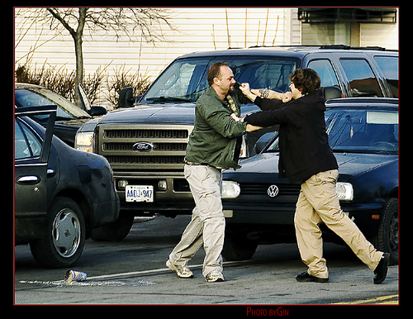

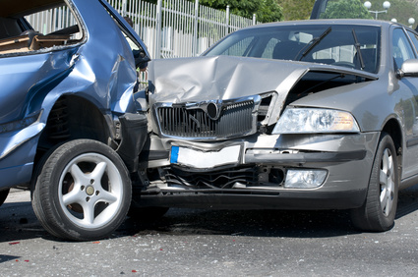

Part 3: Note-taking
Listen to the listening and take notes on this page as you listen. Remember to use key words, abbreviations and symbols. Remember also to organize your notes.

Part 4: Comprehension questions
Use your notes to answer these questions.

1. What is “Road Stories”? (1 point)

2. What is this week’s topic? (1 point)

3. According to Dr. Hughes’s new study, how many people break the law while driving?
Give a percent [%] (1 point)

4. How many suggestions does Dr. Hughes give to drivers to avoid road rage incidents? (1 point)

5. Why is laughter important? (1.5 points)

6. To avoid paying attention to angry drivers, what’s a good thing that we can focus on while driving? (1 point)

7. Why is it important to think about your own driving? (1.5 point)

8. What is the 4th thing we should do protect ourselves while driving? What is the 5th thing we should do? (2 points)

4th =

5th =

Inference: (2 points)
Why is the 5th suggestion really the first thing that you should do?

Vocabulary (from the listening): (2 points)
Write the meaning of “rage”:

Write a sentence using “rage”:

Part 4: Facts (F) or Opinions (O)? (1 point each)

1. According to Dr. Hughes’s research, people are 45 percent more likely to lose their
tempers on the road.

2. There is something about driving that encourages rude and aggressive behavior. .

3. It is easy to stay calm and polite while driving.

4. There are some things you can do to protect yourself while driving.

5. Reading magazines while driving is not safe.

