PART I: TED TALK [Note: Students listen to the lecture & take notes 1 to 2 weeks prior to the final exam. The teacher either lets students keep their notes to study for the exam (meaning no using notes on the exam) or collects the notes and returns them to the students during the final to use. If using a TEDTalk, keep in mind that students are likely to go home and watch the talk again several times to improve their notes. Thus, letting students keep their notes encourages the good students to improve those notes and study for the test just like they would in a university class.

WARM-UP

We read the article “Get Your Own Slang” in class. We also listened to a short lecture about teenagers and slang. What have you learned so far about slang?

Is slang a new phenomenon?
Who tends to create and use slang the most?
Does everyone approve of slang?
Do languages other than English have slang?

In today’s TEDTalk, the speaker argues that slang words like ‘hangry,’ ‘defriend’ and ‘adorkable’ fill crucial meaning gaps in the English language, even if they don't appear in the dictionary. After all, who actually decides which words make it into those pages? The language historian in the talk gives a charming look at the humans behind dictionaries, and the choices they make.
What do “hangry”, “defriend” and “adorkable” mean? Do we need these words?
What do you think defines a “real word”?

PREDICTION
Today, you are going to watch a video lecture that continues our discussion about slang. Before the lecture begins, consider everything that you have learned on this topic. What do you expect to learn from the lecture? Write two predictions below, in the form of questions. (1 pt each)

1.

2.

Note-Taking
You may use the space below to take notes, but the notes will not be graded.

QUESTIONS FROM THE LECTURE – 18 POINTS
9. [critical thinking] Ann Curzan tells a story about a dinner companion who asked her about the word “defriend”. He already knew what the word meant. What can you infer about why he asked her about the word? (2 pts.)

10. According to Anne Curzan, what do most people mean when they say a word isn’t real? (2 pts.)

11. Explain what Anne Curzan means when she says that dictionary editors try to both “appear cutting edge” and “not appear faddish”. (2 pts.)

12. What does the speaker mean when she says that dictionary editors are “just trying to keep up with us”? (2 pts.)

13. [critical thinking] Ann Curzan says that she requires her students to teach her two new slang words at the start of each class. What do you think is the reason for this practice? (2 pts.)

14. When the speaker talks about Lake Superior State University, what does she mean by "banished words”? (2 pts.)

15. This is a two-part question. Be sure to answer both parts.
a) What has the speaker noticed about the “list of banished words” and the list of words being considered for “word of the year”? (1 pt.)

b) Why does she think this happens? (2 pts.)

16. What is the main idea (the TED Talk “idea worth spreading”) of the lecture? (3 pts.)
PART III. ABBREVIATIONS and SYMBOLS – 10 points
What do each of the following symbols and abbreviations mean? (1 pt. each)

<, >
≈ |  | w/in
s/th |  | s/o
vs
w/o |  | w/

PART IV. PRONUNCIATION – 10 POINTS

Suffix Stress Shift [6 points]
How many syllables are in each word below? Which syllable is stressed?

 |  | # of syllables | stressed syllable
EX | substitute | 3 | 1
1. | create
2. | electric
3. | capitalization

Past Tense Endings [3 points]
How many syllables are in each word below? Is the final sound /d/ /t/ or /ed/?

 |  | final sound |  |  | final sound
EX | walked | t
4. | calculated |  | 7. | invented
5. | washed
6. | removed

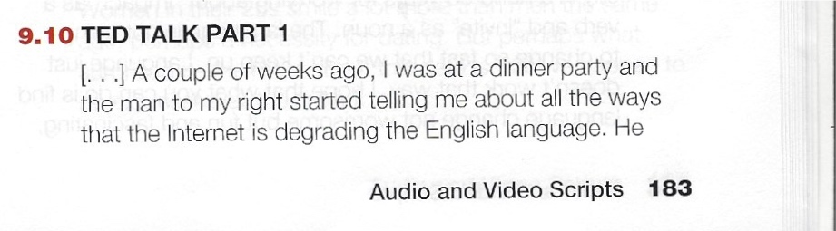
TED TALK, Anne Curzan: “What Makes a Word Real?”

