Should We Have Zoos?
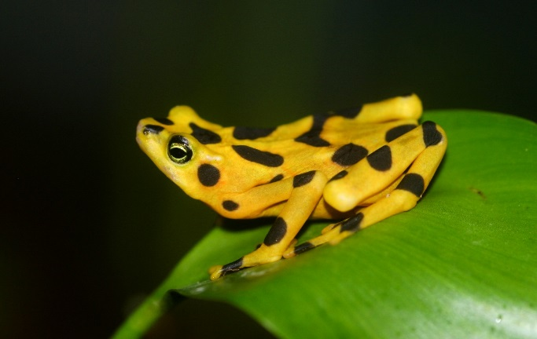
It is uncertain whether there are any critically endangered Panamanian golden frogs left in their native homeland due to a fungal disease which has spread through their habitat. However, they have been bred for years in U.S. zoos in hopes that by maintaining genetic diversity in the species, breeders might be able to reintroduce the frogs to their native forests. Unfortunately, factors including deforestation, construction projects and the presence of toxic fungi leave little possibility that the golden frogs could survive. Should the zoos continue to breed them anyway? This question is part of a larger debate about the role of zoos and aquariums: Are zoos and aquariums a good thing? Should we still have them? Is it wrong to keep animals in captivity for our own enjoyment?

What Is Conservation?
The debate about zoos tends to center around issues of conservation and biodiversity. There are two types of conservation. In-situ conservation efforts are those that focus on protecting a species in its natural habitat, such as creating a protected area in Africa to help elephants thrive. The other type of conservation is called ex-situ conservation, and it focuses on maintaining species survival somewhere outside the animal's natural habitat, such as the golden frog project. Zoos play a role in both types of conservation. Though housing the animals is a clear example of ex-situ conservation, many zoos have partnerships and funding structures that support in-situ conservation also. The Wildlife Conservation Society (WCS) has programs in nearly 50 countries that work to protect some of the world’s most at-risk species and habitats. In Indonesia, for example, WCS has experts working to protect the Sumatran tiger.
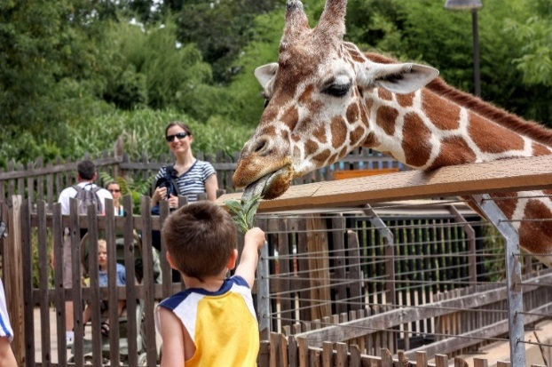
What Are the Main Arguments Supporting Zoos?
Zoos’ ability to merge in-situ and ex-situ conservation is not the only argument supporting them. Zoos promote conservation through educational programs that inform the public about biodiversity and conservation. The San Diego Zoo, for instance, offers tours, camps, and art and photography courses. The Association of Zoos and Aquariums (AZA) believes these efforts are critical to public understanding of conservation. According to the AZA, more than 180 million visitors to its zoos participate in educational programs each year, including more than 50 million students.
A second major argument in favor of zoos is that they preserve genetic diversity of species. Zoos have specialized plans for threatened or endangered species such as chimpanzees. The plans involve breeding and transferring animals within the network of AZA-accredited zoos. Each plan identifies population goals and recommendations to ensure a healthy population varying in genetics and demographics.
Another reason people support zoos is because they think animals there are treated well. Many zoos now emphasize creating habitats that look and feel more natural for the animals. Humans have kept wild animals in captivity since ancient times, and if animals are going to be kept, a well-managed zoo is the best place for them. Over the last 20 years, many zoos have transformed drab concrete and metal enclosures into exhibits with more enrichment for the animals. Their homes mirror their natural habitat, with trees, ropes for climbing and artificial "natural" features like caves.
Lastly, many zoos are able to rescue animals from abuse or mishandling. In 2002, U.S. authorities seized six abused and malnourished polar bears from a Mexican circus that was touring Puerto Rico. The Suarez Brothers circus had abandoned them in sweltering heat when they realized they could not bring polar bears to the next country on their tour. After being moved to zoos in the U.S., the bears recovered and had access to large water tanks and open spaces.

What Are the Main Arguments Against Zoos?
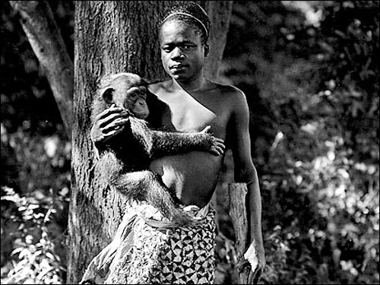
Many people believe that zoos exploit animals for human enjoyment. The history of zoos is full of instances of animals and even humans used for entertainment purposes. In the 19th century, many had "cultural exhibits" which displayed animals and also people, against their will, from certain regions. In the U.S., a man from Africa was put on display in the Bronx Zoo in 1906 after the United States had abolished slavery. Regardless of what they are like today, their history raises numerous ethical concerns.
Opponents of zoos also believe zoo animals suffer physically and mentally as their social, behavioral and physical needs cannot be met in unnatural man-made environments. Although conditions in zoos have improved immensely, zoos around the world differ widely in quality and standards of care for their animals. Often, laws to protect zoo animals have not been effective.
Even with more natural enclosures, many believe it is wrong to keep a wild animal in captivity regardless of what its home looks like. Some activists say that all living things should have personhood, meaning they are entitled to rights just as people are. Holding wild animals violates their rights, they say.
Critics also point to how expensive zoos are. They believe that zoos are a massive misuse of resources. Spending money (sometimes upwards of $1 million a year) to create a natural-looking elephant enclosure in the U.S. is less effective for overall conservation efforts. That same money could be better spent in a community-based conservation project in Africa. The cost of admission to a zoo ($50) could feed a family of four in Kenya for a month, based on World Food Program estimates. That could be one fewer person who decides to become a poacher, or someone who hunts animals illegally. With about 165 million people visiting zoos in the U.S. each year, that money could go a long way in meeting needs in conservation hotspots.

Conclusion
Though it doesn’t seem as if zoos are going away any time soon, the debate about them will surely continue. Changes have happened in many zoos because of this debate. Also, there has been an increased focus on wildlife reserves and parks where animals are protected in-situ and people can visit to see them. Accessibility is an issue, though. To see a wild gorilla in the African country of Rwanda, for instance, you’d have to pay $750 to enter the park, with no guarantee that you’ll see one.
Each side of the debate has strong points. There’s no denying the joy and awe one can experience when encountering an animal up close. But there is also something sad about a wild animal living somewhere it doesn’t quite belong. Perhaps Pulitzer Prize-winning writer Thomas French put it best: “What's the reality of being inside a zoo, for the animals and for the people who love and care for those animals? There's a lot of joy, and there's a lot of loss.”

